**1.1 Introduction**

Digital filtering is a widely used technique that is common in many fields of science and engineering.  Filters remove unwanted signals and noise from a desired signal.  There are many different kinds of filters, including low pass, high pass, band pass and band stop filters.  In just the category of low pass filters, there is a large collection of filters that famous engineers and mathematicians have invented, including Hanning, Hamming, Blackman, Kaiser and Tukey windows.  In this project, we will show you how to use Matlab’s filter function to remove a high frequency signal from a desired signal.

**1.2 Motivation:**

Smoothing is how we discover important patterns in our data while leaving out things that are unimportant (i.e. noise). We use filtering to perform this smoothing. The goal of smoothing is to produce slow changes in value so that it's easier to see trends in our data. In the following project, the filter function is used to remove high frequency interference from a lower frequency signal.

* 1. **Objective:**

In order to get a clean and sharp signal, noise reduction is the main issue in signal smoothing.One goal in image restoration is to remove the noise from the image in such a way that the "original" signal is discernible.

Our project methodology includes the following:

1. Use MATLAB to simulate the processing technique.

2. Implement the technique with assembly language on a TMS320C542-based DSKplus board to perform the same operation.

3. Carefully locating the memory blocks where we will store our original and output signal.

4. Comparing our results from MATLAB and DSP outputs.

* 1. **What is Filtering?**

Digital filters are central to almost every signal processing system. Filters eliminate unwanted artifacts from signals to enhance their quality and prepare them for further processing. Digital filters are used in a variety of signal processing tasks including outlier and noise removal, waveform shaping,  signal smoothing and signal recovery.

**2.2 Types of Filtering?**

* Hanning .
* Kaiser.
* Tukey windows.
* Hamming.
* Blackman

### 2.1 Working process

### The filter function is used to remove high frequency interference from a lower frequency signal.  The most important lines in the code are as follows:

### f1.JPG

### A simple low pass filter with a pole at +1 is used with the filter function.  This filter has a transfer function of

### f2.JPG

### More sophisticated filters, which are presented on following code, can be used by setting the a and  b parameters as follows:

### f3.JPG

That example uses a Hanning Window, but any filter can be used by setting the b parameter to a different value

Here are the figures that the code presented below generates.  The first figure shows the original signal that we wish to retain.  The second figure shows the original signal combined with interference at a frequency that is ten times higher.  The third figure shows the signal after filtering with the simple low-pass filter.  Note that the high frequency interference is gone, but the original signal has been distorted.  Keeping the information in the desired signal intact is one of the main challenges for engineers using filters.  The fourth and fifth figures show the frequency responses of the signals from the combined signal before and after filtering.  These figures show the Fourier transforms of the second and third figures.  Note that the signal at 10 Hz is greatly attenuated after filtering, while the signal at 1 Hz is almost the same as before filtering.

**3.1 MATLAB Code**

%Parameters

clc;

clear;

Fs = 100;

tmax = 5;

Nsamps = tmax*Fs;

%Create Initial Signals

t = 1/Fs:1/Fs:tmax;

s1 = 10*cos(2*pi*t);

s2 = 2*cos(20*pi*t + pi/4);

s3 = s1 + s2;

%Plot in Time Domain

%Original

figure

subplot(3,2,1)

plot(t,s1)

xlabel('Time (s)')

ylabel('Amplitude (V)')

title('Original Signal')

ylim([-15 15])

%Original + High Freq

subplot(3,2,2)

plot(t,s3)

xlabel('Time (s)')

ylabel('Amplitude (V)')

title('Original Signal Combined With High Frequency Signal')

ylim([-15 15])

%Filter Signals

%Simple Low-Pass Filter

b = 1;

a = [1 -1];

%Apply Filter

s3_f = filter(b,a,s3);

%Scale Output

s3_f = s3_f/15;

%Plot Filtered Signal

subplot(3,2,3)

plot(t,s3_f)

xlabel('Time (s)')

ylabel('Amplitude (V)')

title('Filtered Signal')

ylim([-15 15])

%Frequency Domain

f = Fs*(0:Nsamps/2-1)/Nsamps; %Prepare freq data for plot

%Original + High Freq

s3_fft = abs(fft(s3));

s3_fft = s3_fft(1:Nsamps/2); %Discard Half of Points

subplot(3,2,4)

plot(f, s3_fft)

xlabel('Frequency (Hz)')

ylabel('Amplitude')

title('Frequency Response of Combined Signal Before Filtering')

ylim([0 3000])

%Filter Signals

s3_f_fft = abs(fft(s3_f));

s3_f_fft = s3_f_fft(1:Nsamps/2); %Discard Half of Points

subplot(3,2,5)

plot(f, s3_f_fft)

xlabel('Frequency (Hz)')

ylabel('Amplitude')

title('Frequency Response of Combined Signal After Filtering')

ylim([0 3000])

**4 Result & Discussion**

**4.1 Sample Output Snapshot**

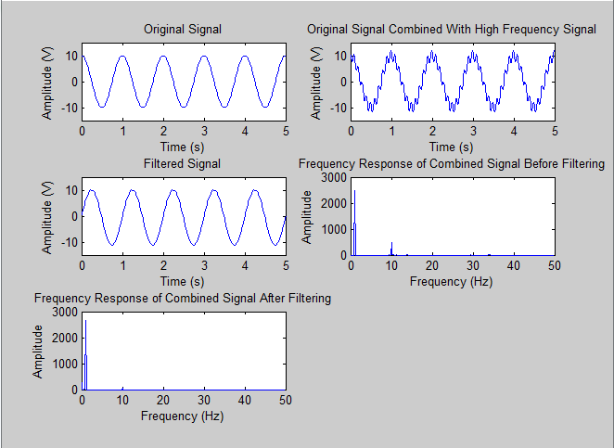

**Figure 1: Output of the digital filter for removing noise from a signal**

**Conclusion**

This is the process of filtering a signal. We combine a high frequency signal with the original signal then by the process of filtering we get the original signal. Here in our code we have some limitations. It is not clear how much noise in this process can be removed. Otherwise it is a well enough process to remove noise from a signal.



***Dept Name:*** *Computer Science & Engineering*

***Course Name:*** *Digital Signal & Image Processing Laboratory*

***Course Code*:** *CSE-4204*

***A Project Report***

***On***

**Digital Filtering for removing noise from a signal with MATLAB**

**Submitted To:**

Md. Yasir Arafat

Lecturer

Dept. of Computer Science & Engineering

Jessore University of Science & Technology

**Submitted By:**

Roll: 100101, 100104, 100107, 100111, and 100125

4th Year 2nd Semester

Department of Computer Science & Engineering.

Jessore University of Science & Technology, Jessore.

**Submission Date: 04-08-2015**